Pontifícia Universidade Católica do Paraná

Lógica Matemática – Lista de Exercícios 6

Nome (INDIVIDUAL): Rafaela Vecchi Pelentier

Regras de Inferência:

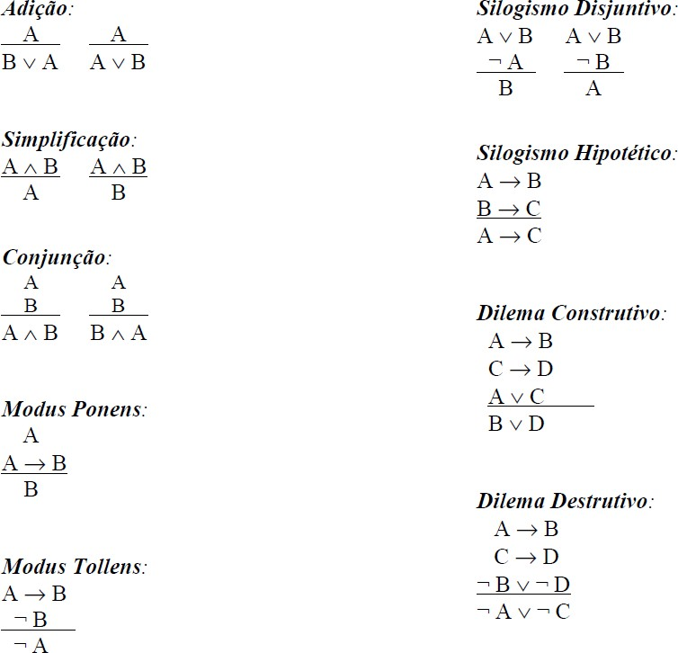

**Exercícios:**

1. Indique a regra de inferência que justifica a validade de:
   1. { ( p  q ) } **⊢** ( p  q )  ¬ r

|  |  |
| --- | --- |
| 1. ( p  q ) | prem |
| 1. (p  q) v r | Adição (1) |
| 1. (p  q) v ~ r | (1,2) |

* 1. { ¬p  ( q  r ) } **⊢** ¬ p

|  |  |
| --- | --- |
| 1. ¬p  ( q  r) | prem |
| 1. ¬p | Simplificação (1) |

* 1. { (p  q) , (q  ¬r) } **⊢** ( p  ¬ r )

|  |  |
| --- | --- |
| 1. (p  q) | prem |
| 1. (q  ¬r) | prem |
| 1. (p  q) ^ (q  ¬r) | Conjunção (1,2) |
|  |  |

* 1. { p  ( q  r ) , p } **⊢** q  r

|  |  |
| --- | --- |
| 1. p | prem |
| 1. p  ( q  r ) | prem |
| 1. q  r | Modus ponens (1,2) |

* 1. { ( q  r )  ¬p , ¬ ¬p } **⊢** ¬ ( q  r )

|  |  |
| --- | --- |
| 1. ( q  r )  ¬p | prem |
| 1. ¬ ¬p | prem |
| 1. ~ ( q  r ) | Modus tollens (1,2) |

* 1. { ( p  q ) , ( r  ¬ s ) } **⊢** ( p  q )  ( r  ¬ s )

|  |  |
| --- | --- |
| 1. ( p  q ) | prem |
| 1. ( r  ¬ s ) | prem |
| 1. ( p  q ) ^ ( r  ¬ s ) | Conjunção (1,2) |

* 1. { ( p  q )  ( ¬ p  r ) , ¬ ( ¬ p  r ) } **⊢** ( p  q )

|  |  |
| --- | --- |
| 1. ( p  q )  ( ¬ p  r ) | prem |
| 1. ¬ ( ¬ p  r ) | prem |
| 1. ( p  q ) | Silog. Disjuntivo (1,2) |

1. Indique uma possível conclusão para:
   1. { ( s  t )  ( r  q ) , ( r  q )  ¬ p }

|  |  |
| --- | --- |
| 1. ( s  t )  ( r  q) | prem |
| 1. ( r  q )  ¬ p | prem |
| 1. ( s  t )  ¬ p | Silogismo hipotético (1,2) |

* 1. { ( p  q )  ¬ ( r  s ) , ¬ ¬ ( r  s ) }

|  |  |
| --- | --- |
| 1. ( p  q )  ¬ ( r  s ) | prem |
| 1. ¬ ¬ ( r  s ) | prem |
| 1. ~ ( p  q ) | Modus tollens (1,2) |

* 1. { s  ( r  t ) , ¬ s }

|  |  |
| --- | --- |
| 1. s  ( r  t ) | prem |
| 1. ¬ s | prem |
| 1. ( r  t ) | Silogismo disjuntivo (1,2) |

* 1. { p  ( r  ¬ s ) , ( r  ¬ s )  t }

|  |  |
| --- | --- |
| 1. p  ( r  ¬ s ) | prem |
| 1. ( r  ¬ s )  t | prem |
| 1. p  t | Silogismo hipotético (1,2) |

* 1. { p  r , ¬ q  ¬ s , p  ¬ q }

|  |  |
| --- | --- |
| 1. p  r | prem |
| 1. ¬ q  ¬ s | prem |
| 1. p  ¬ q | prem |
| 1. r  ¬ s | Dilema construtivo (1,2,3) |

* 1. { ¬ p  ¬ q , ¬ ¬ q }

|  |  |
| --- | --- |
| 1. ¬ p  ¬ q | prem |
| 1. ¬ ¬ q | prem |
| 1. ¬ p | Silogismo disjuntivo (1,2) |

* 1. { p  ( ¬ r  q ) , ¬ ( ¬ r  q )  ¬ s , ¬ q  s }

|  |  |
| --- | --- |
| 1. p  ( ¬ r  q ) | prem |
| 1. ¬ ( ¬ r  q )  ¬ s | prem |
| 1. ¬ q  s | prem |
| 1. ¬ p  ¬ ¬ q | Dilema destrutivo (1,2,3) |